**eVouchers (site to view pay check, W-2, and attendance information)**

FIRST TIME USERS:

Go to: www.fowlervilleschools.org

Click on **Staff Resources**

Click on **RECORD OF PROFESSIONAL DEVELOPMENT**

Select **Fowlerville Community Schools** in drop down and click **OK**

Click on “**Not a registered user? Click here!**”

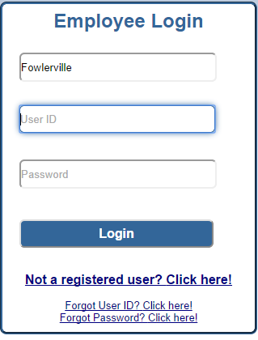

**Fill in all required fields and click Next**

Note:

Enter your birthdate AND

employee ID number

OR last 4 of social security number.

Employee ID: Email Pam Harris in the Business Office if you need your employee ID. (HarrisP@fowlervilleschools.org)

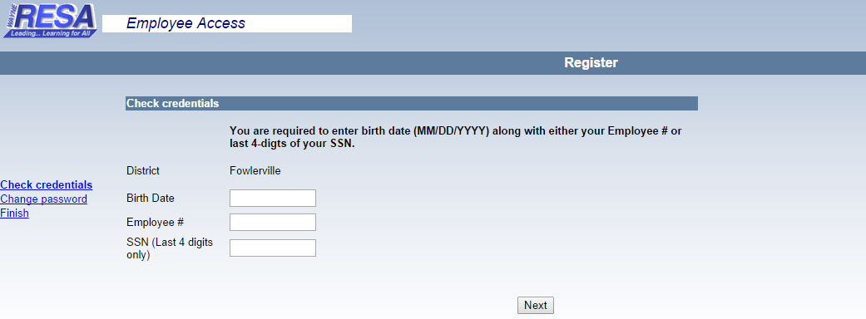

Set and confirm your password:



NOTE: - User ID – will be the first 6 letters of your last name and first initial .

PLEASE SELECT A REALLY SECURE PASSWORD… SEE BELOW for IDEAS.

Guidelines for selecting a password:

1. **Do not** **use:**  your login ID, your name or a loved one’s name, your hobbies or pets’ names, special dates such as birthdays, anniversaries, etc.
2. The password must be a minimum of 6 characters.
3. Make it something you can remember. **\* Don’t write it down * !**
4. Make it something you can type easily and quickly.
5. Use a combination of letters,(upper and lower case letters should be used), special characters and numbers. NO SPACES.
6. Your password must be entered exactly, including the correct upper and lower case letters.
7. Carefully distinguish uppercase from lowercase, O’s (oh’s) from 0's (zeros).

**Viewing your eVoucher information:**

Go to: www.fowlervilleschools.org

Click on **Staff Resources**

Click on **RECORD OF PROFESSIONAL DEVELOPMENT**

Select **Fowlerville Community Schools** in drop down and click **OK**

Enter your User ID and Password and click “Login”



Click on the tab called “**Payroll”**, then use the drop down to select the pay stub that you wish to view. 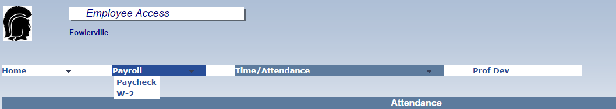

Your voucher will appear on the screen. You can print a copy of the voucher now if you wish to. **PLEASE TAKE NOTE OF YOUR EMPLOYEE #**. You will need this to change your password.

You can also click on the W-2 “drop-down” under Payroll to view all past W-2’s and/or click on the Time/Attendance tab for attendance information.



If you ever forget your ID or password, you can follow the links to get your ID and reset your password:

Go to: www.fowlervilleschools.org

Click on **Staff Resources**

Click on **RECORD OF PROFESSIONAL DEVELOPMENT**

Select Fowlerville Community Schools in drop down and click **OK**

Click on “Forgot Password” or “Forgot Login ID”



Fill in the blanks and click Next

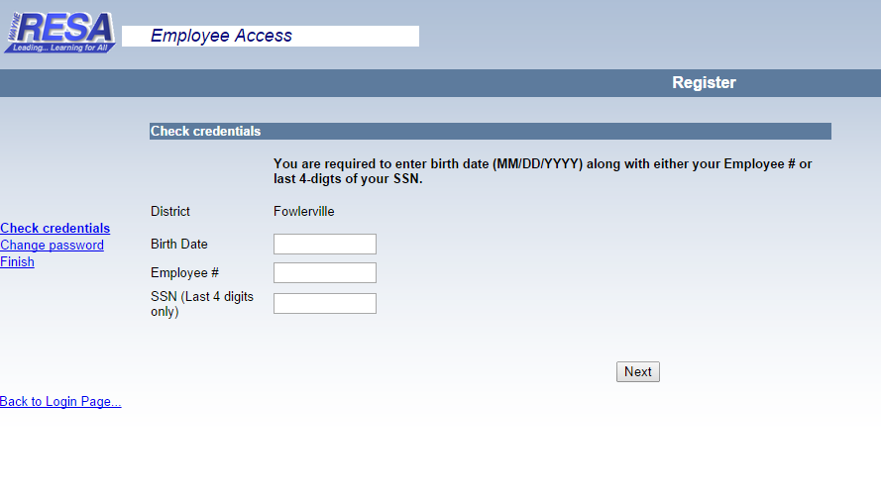

**The system will walk you through the reset process.**

**REVISON DATE 9-26-2014**

**District/Shared/Forms/Business Office Procedures and Forms/Forms - Separate**